Practice Be Going To

**SHORT ANSWER. Write the word or phrase that best completes each statement or answers the question.**

*Complete the conversations. Use the words in parentheses to write* yes / no *questions in the future with* be going to*. Then complete the short answers and the statements. Use contractions when possible.*

1) **A:** 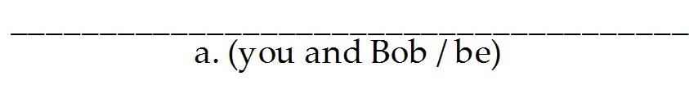 home tomorrow night?

**B:** Yes,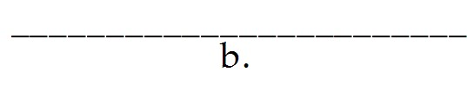. We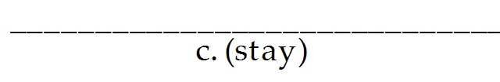 home all weekend.

2) **A:** It's getting very cloudy.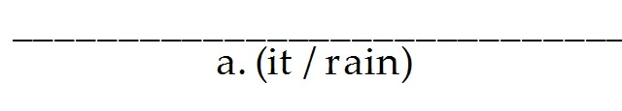 today?

**B:** No,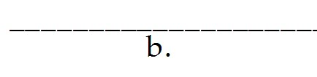. It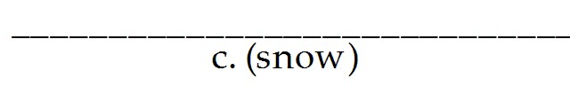 .

**A:** Great! 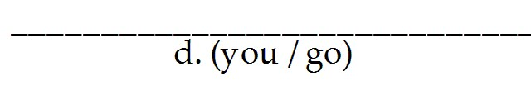 skiing this weekend?

**B:** No,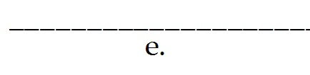 . My cousin Al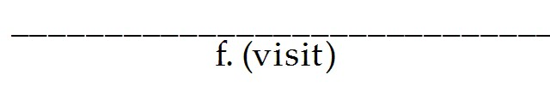 me.

**A:** 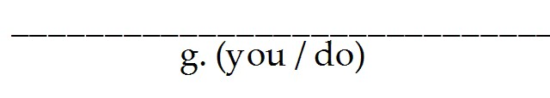 anything interesting?

**B:** Yes,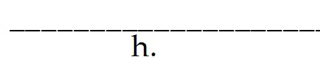 . I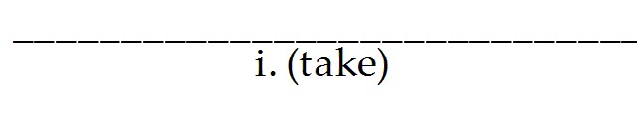him to the new

Greek restaurant on Friday night. Then, on Saturday night, we

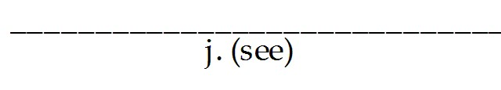the new play at the Second Stage.

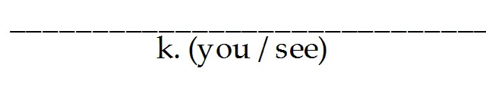it?

**A:** No,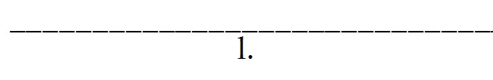 I don't like plays.

*Complete the conversations with* wh- *questions. Use the words in parentheses and* be going to.

3) **A:** 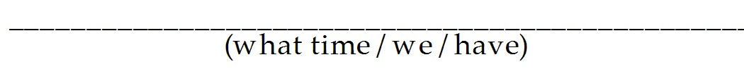lunch?

**B:** Around one-thirty.

4) **A:** 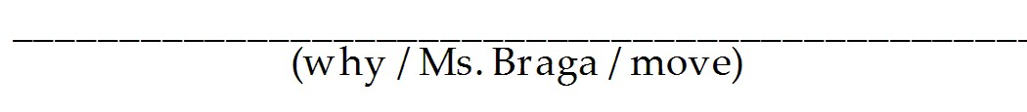to an apartment?

**B:** Because she wants a small apartment.

5) **A:** 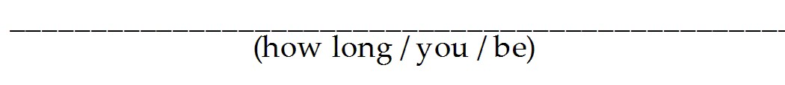in Phoenix?

**B:** Almost a month.

*Complete the conversations with* wh- *questions. Use the words in parentheses and* be going to.

6) **A:** 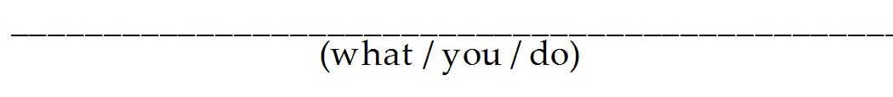this weekend?

**B:** Sleep.

7) **A:** 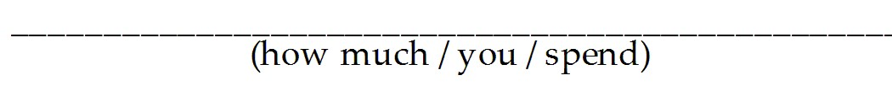on food this week?

**B:** Not much. I'm on a diet.

8) **A:** ?

**B:** A week.

9) **A:** 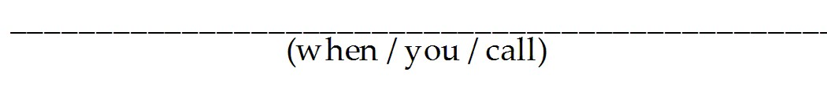your parents?

**B:** Tomorrow night.

10) **A:** 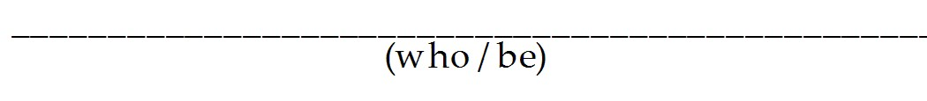at your anniversary party?

**B:** All our friends and family.

*Correct this conversation. There are eleven mistakes.*

11) **A:** What we're going to have for dinner tonight?

**B:** I'm going make spaghetti.

**A:** Are you going prepare your famous meat sauce?

**B:** No, I'm no going to make any sauce.

**A:** How can we have spaghetti without sauce? It's going to tastes awful.

**B:** We going to have sauce, silly. I'm just no going to make it myself. I bought a

bottle of sauce at the supermarket yesterday. I'm going use that.

**A:** That sounds great. What time we're going to eat?

**B:** At around seven. Oh, and I want salad for dinner too.

**A:** That sounds good too. Who going to make the salad?

**B:** You do!

*Correct this conversation. There are eleven mistakes.*

**A:** What we're going to have for dinner tonight?

**B:**I'm going make spaghetti.

**A:**Are you going prepare your famous meat sauce?

**B:**No, I'm no going to make any sauce.

**A:**How can we have spaghetti without sauce? It's going to tastes awful.

**B:**We going to have sauce, silly. I'm just no going to make it myself. I bought a bottle of sauce at the supermarket yesterday. I'm going use that.

**A:**That sounds great. What time we're going to eat?

**B:**At around seven. Oh, and I want salad for dinner too.

**A:**That sounds good too. Who going to make the salad?

**B:**You do!

*Correct this conversation. There are eleven mistakes.*

**A:** What we're going to have for dinner tonight?

**B:**I'm going make spaghetti.

**A:**Are you going prepare your famous meat sauce?

**B:**No, I'm no going to make any sauce.

**A:**How can we have spaghetti without sauce? It's going to tastes awful.

**B:**We going to have sauce, silly. I'm just no going to make it myself. I bought a bottle of sauce at the supermarket yesterday. I'm going use that.

**A:**That sounds great. What time we're going to eat?

**B:**At around seven. Oh, and I want salad for dinner too.

**A:**That sounds good too. Who going to make the salad?

**B:**You do!

*Correct this conversation. There are eleven mistakes.*

**A:** What we're going to have for dinner tonight?

**B:**I'm going make spaghetti.

**A:**Are you going prepare your famous meat sauce?

**B:**No, I'm no going to make any sauce.

**A:**How can we have spaghetti without sauce? It's going to tastes awful.

**B:**We going to have sauce, silly. I'm just no going to make it myself. I bought a bottle of sauce at the supermarket yesterday. I'm going use that.

**A:**That sounds great. What time we're going to eat?

**B:**At around seven. Oh, and I want salad for dinner too.

**A:**That sounds good too. Who going to make the salad?

**B:**You do!

*Correct this conversation. There are eleven mistakes.*

**A:** What we're going to have for dinner tonight?

**B:**I'm going make spaghetti.

**A:**Are you going prepare your famous meat sauce?

**B:**No, I'm no going to make any sauce.

**A:**How can we have spaghetti without sauce? It's going to tastes awful.

**B:**We going to have sauce, silly. I'm just no going to make it myself. I bought a bottle of sauce at the supermarket yesterday. I'm going use that.

**A:**That sounds great. What time we're going to eat?

**B:**At around seven. Oh, and I want salad for dinner too.

**A:**That sounds good too. Who going to make the salad?

**B:**You do!

1) a. Are you and Bob going to be

b. we are

c. 're going to stay

2) a. Is it going to rain

b. it isn't / it's not

c. 's going to snow

d. Are you going to go

e. I'm not

f. 's going to visit

g. Are you going to do

h. we are / I am

i. 'm going to take

j. 're going to see

k. Are you going to see

l. I'm not

3) What time are we going to have

4) Why is Ms. Braga going to move

5) How long are you going to be

6) What are you going to do

7) How much are you going to spend

8) How long is this trip going to take

9) When are you going to call

10) Who is going to be

11) are we

**A:** What ~~we're~~ going to have for dinner tonight?

to

**B:** I'm going ∧ make spaghetti.

to

**A:** Are you going ∧ prepare your famous meat sauce?

not

**B:** No, I'm ~~no~~ going to make any sauce.

taste

**A:** How can we have spaghetti without sauce? It's going to ~~tastes~~ awful.

We're not

**B:** ~~We~~ going to have sauce, silly. I'm just ~~no~~ going to make it myself. I bought a

to

bottle of sauce at the supermarket yesterday. I'm going ∧ use that.

are we

**A:** That sounds great. What time ~~we're~~ going to eat?

**B:** At around seven. Oh, and I want salad for dinner too.

Who's

**A:** That sounds good too. ~~Who~~ going to make the salad?

are

**B:** You ~~do~~!